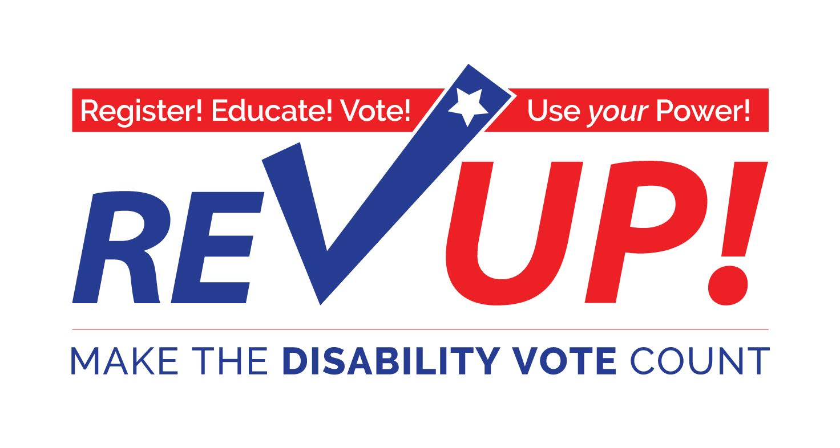

**[State] Toolkit**

Presented by

**[insert organization name]**

*Special thanks to The Texas Disability Project for creating the initial Toolkit*

**The American Association of People with Disabilities**

[www.aapd.com/REVUP](http://www.aapd.com/REVUP)

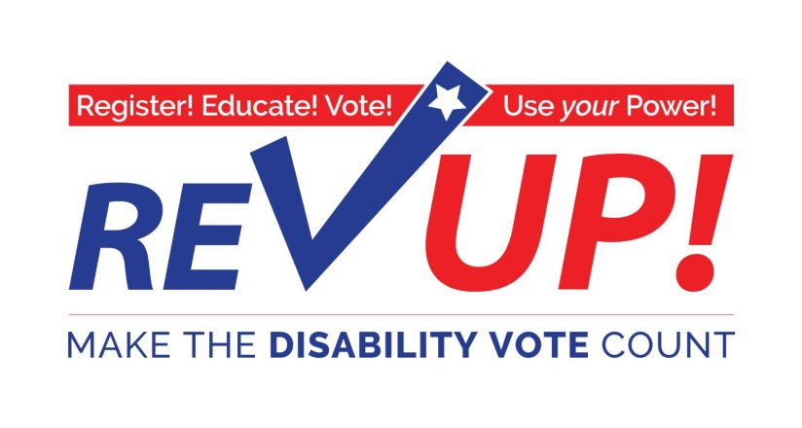

**Table of Contents**

Letter to Disability Rights Advocates 4

The Disability Vote can make a difference! 6

REV UP [organization name] 7

REV UP Talking Points 8

Pledge to REV UP 9

The Ripple Effect of the Disability Vote 10

Definition of the Disability Vote 11

Where, When, and How to Vote 12

Voting Dates 13

Your Vote Matters 14

Voting Questions 15

Voting Rights and Accommodations 16

How to Register to Vote in [state] 17

Helpful Information for Voters with Disabilities 20

A Basic Guide to Voting Place Accessibility 21

Polling Place Survey 23

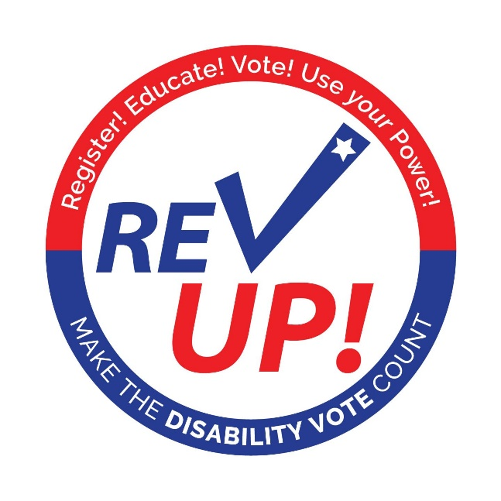

Dear Disability Rights Advocates:

In July 2015 we celebrated the 25th anniversary of the Americans with Disabilities Act (ADA).

We can take great pride in the historic advances we have made in the community integration of people with disabilities of all ages since the passage of Section 504 of the Rehabilitation Act of 1973. No matter what the issue— education, housing, transportation, personal assistance services, employment, recreation, adaptive technology, durable medical equipment, or health care, we can see the advances that have improved our lives and moved us closer to true equality.

This has come about by working together and implementing a strategy that has included legislative, legal, direct action, and educational tactics. These tactics are part of our overall goal to bring about the community integration promised in the ADA.

We cannot rest on our past victories. We must build on the past and move forward using the power we have acquired. This power can be exerted if we ***Make the DISABILITY VOTE Count!*** Policymakers are influenced by large numbers of people turning out to vote in the primaries and the general elections. This reality is why we started the **REV UP Campaign**.

The American Association of People with Disabilities (AAPD) is a convener, connector, and catalyst for change, increasing the political and economic power of people with disabilities. The focus of the **REV UP Campaign**is to get more people with disabilities and our supporters registered and voting!

This Toolkit is designed to help you begin organizing in your state. Effective REV UP Campaigns will convene state and local disability organizations, such as centers for independent living (CIL) and protection and advocacy (P&A) organizations, to amplify this message and reach more people with disabilities.

If you need assistance getting connected to CILs or P&As in your state please contact AAPD at [communications@aapd.com](mailto:communications@aapd.com?subject=RevUp). We’ll be happy to make an introduction.

***Register! Educate! Vote!***

***Use your Power!***

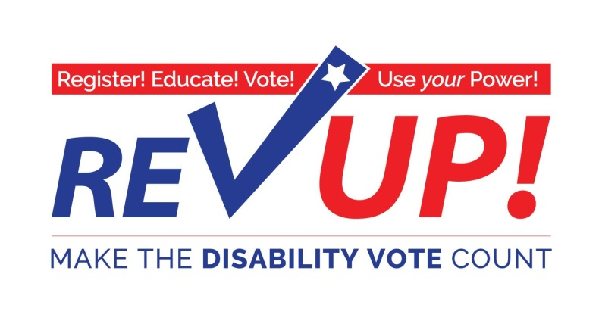

***[insert name for people in your state, ex. Texans] with disabilities CAN influence the outcome  
 of the [insert date of state primary] [insert state] Primary and General Election***

**‘More than any time in memory:**

* Elected leaders and political candidates are recognizing the 57 MILLION Americans with disabilities—from birth to advanced age—as a powerful, important constituency
* Issues important to people with disabilities must be part of the platform for any candidate running for public office.

**Join thousands of Americans with disabilities in this important and historic effort!**

***Don’t Mourn…Organize, Register, and VOTE!  
Onward to November 8, 2016! Make the DISABILITY VOTE Count!***

**For more information:**

**[Insert information about your organization – phone number, email, address, mission statement, etc.]**



**“Vote as if your life depends on it**

**— *because it does!”***

Justin Dart, Jr., Texan, patriot, father of the ADA.

***The November 8th election will be one of the most important elections in over a decade.***

The disability community—people with disabilities, family members, attendants, providers, professionals, advocates and supporters—has a major stake in the outcome of this election.

The ***Disability Vote*** can make a difference on issues such as:

* Adequate funding and coverage for Medicaid acute and long term services and supports.
* Waiting lists for home and community services.
* Consolidation and closure of public institutions.
* Integrated employment at no less than minimum wage.
* Accessible, affordable, integrated housing.
* Adequate funding for quality public and higher education.
* Quality Medicaid managed care with strict accountability measures.
* Recruitment and retention strategies for improved wages and benefits for community attendants.
* Implementation and enforcement of the “most integrated setting” requirements in the Americans with Disabilities Act (ADA).

***REV UP! 2016: A Project of [insert name of your organization]***

**The mission of [insert mission of your organization]**

**WHY?** There are approximately 57 million Americans with disabilities. People with disabilities represent 15% of the total voting population.

However, in the 2012 election:

* 57.2% of people with disabilities ***DID NOT VOTE*!**
* 30% of people with disabilities said they wanted to vote but were unable to
* 72% of polling places ***WERE NOT ACCESSIBLE!***

**HOW?** To make participation in the election process as simple as possible, REV UP 2016 encourages individuals to take these steps:

**Step 1** Download a *REV UP 2016 Toolkit* from [www.aapd.com/REVUP](http://www.aapd.com/REVUP). The Toolkit includes information and resources to help people with disabilities and supporters register and vote.

**Step 2:** Make sure YOU are registered to vote and sign the ***REV UP Pledge to Vote!***

**Step 3:** Distribute information and registration forms to your friends for them to complete to ensure that they are registered to vote.

**Step 4:** Encourage others to request a *REV UP 2016 Toolkit* and sign the *REV UP Pledge to Vote*.

**Step 5:** Join the [name of your organization] (it’s free!) by completing and returning the TDP volunteer form.

**Step 6:** Use the *Polling Place Survey* (at the end of this Toolkit) when you vote to help us collect information about the accessibility of polling places nationally.

**Important pointers for talking to people about voting:**

|  |  |
| --- | --- |
| **DO:** | **DO NOT:** |
| * Encourage family, friends and others to register to vote and, if eligible, to request a ballot by mail. * Explain and emphasize the importance of the disability vote and the rights of individuals with disabilities to vote. * Encourage friends, colleagues, and family members to request a *REV UP 2016 Toolkit* from [www.aapd.com/REVUP](http://www.aapd.com/REVUP) | * Recommend, endorse, or encourage support for one candidate or party over another. * Tell the people you’re registering which party to register under or who to vote for. * Coordinate activities with a candidate or campaign or political party * Target your registration efforts toward any particular ideological group, party, or issue. |
|  | |
| **Guide for talking to others about voter registration and *REV UP 2016* :**  **Ask the question, “Are you registered to vote?”** | |
| **If the answer is NO:** | **If the answer is YES:** |
| **Would you like register? It’s easy!**   * Provide them with the registration form. * Forms are available for download from the [insert state] Secretary of State’s (SOS) office.   **Would you like assistance to complete the registration form?**   * You may assist them in completing the registration form.   **You need to mail the registration form to the County Voter Registration Office**.   * The address for the County Voter Registration Office is on the voter registration form or available on the Secretary of State website: [insert state SOS web address] * You may assist them in mailing in the form.   **Voter Registration Forms must be sent in to the County Voter Registration Office by [insert submission deadline for your state].**  **Remind them that general election day is November 8, 2016.** | **Do you need to apply for a ballot by mail?  It’s easy!**   * Provide them with the information about voting by mail. * Applications can be downloaded from the Secretary of State website.   **Would you like assistance to complete the application for a ballot by mail?**   * You may assist them in completing the absentee ballot application.   **The applicant needs to mail the application to the County Voter Registration Office.**   * The address for the County Voter Registration Office is on the voter registration form or on the SOS website. * Tell them to mail in the form.   **Voting by mail applications must be submitted to the County Voter Registration Office by [date].**  **Ballots must be submitted to the County Voter Registration Office by November 8, 2016.**  **Remind them that general election day is November 8, 2016.** |

**Join the REV UP Campaign**

**with**

**[insert organization name]**

***Together we have the power to change our communities!***

______ Add my name to get information on the {insert organization name]

______ I want to VOLUNTEER TIME, building the REV UP Campaign

* Social Media
* Brochure Development
* ListServe
* Outreach

***I want to make the DISABILITY VOTE count! SIGN ME UP!***

Name: ______________________________________________________________________________

Organization: ________________________________________________________________________

Address: ________________________________________________________________________

City: ___________________________________ State: ________ Zip: __________________

Email: ___________________________________________ Phone: ________________________

Complete the form and return by email to: [insert email for your organization]

To return, email [insert email address] or mail to:

[insert organization mailing address]

**Questions?**

Send email to [insert email address] or call [insert phone number]



***Ripple Effect of the Disability Vote***

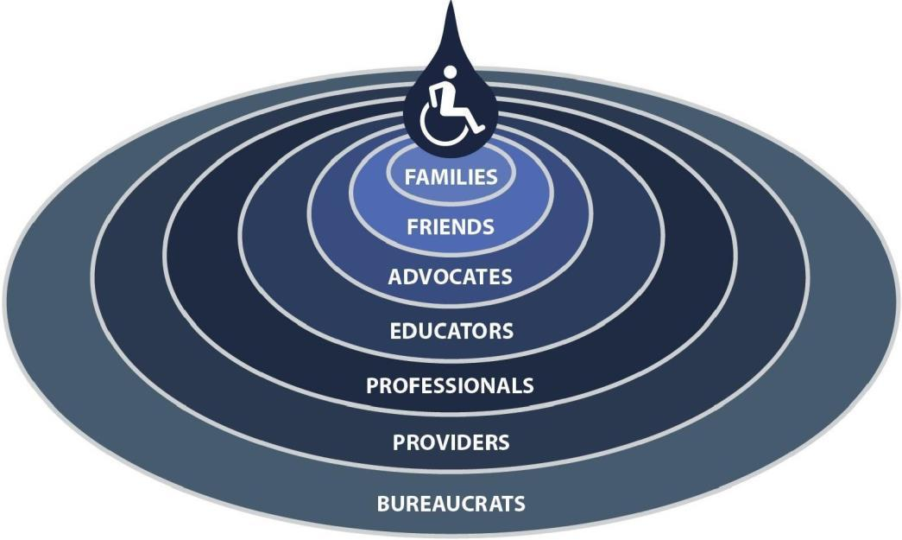

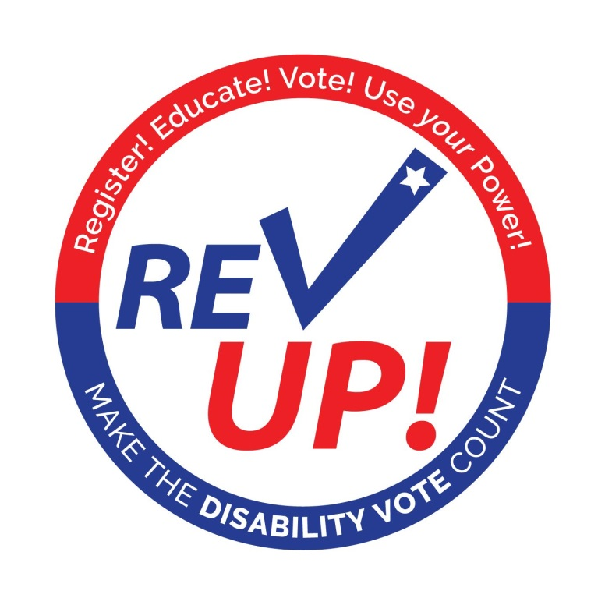

***Definition of the DISABILITY VOTE:***

1. People with disabilities
2. Family members and friends
3. Advocates
4. Educators
5. Professionals
6. Providers
7. Bureaucrats
8. Supporters

**Need information about when, where, and how to register and vote?**

The [insert organization name] recommends the following resources to find what you need. Need more help? Call [insert organization phone number] or send an email to [insert organization email].

**[insert state] Secretary of State’s Office**

* [insert state info: phone, email, website, voter registration page, page for voters with disabilities (if applicable), county voter registration info, mail in ballot info, etc.]

**[insert state] Department of Public Safety** *(or the applicable Department in your state)*

* [insert state info: Election identification certificates info, general information, phone number, email address, website, etc.]

**[insert organization name] Voting Resources**

* [insert organization info: website, phone number, email, etc.]

**AAPD REV UP Voting Resouces**

* [www.aapd.com/REVUP](http://www.aapd.com/REVUP)

**[insert other state specific voting resources]**

* [websites, phone numbers, emails, etc.]

### 2016 Voting Dates to Remember

**PRESIDENTIAL PRIMARIES**

* [insert state specific primary information]

**NOVEMBER GENERAL ELECTION**

* **[insert state specific date]**: Last day to register to vote in the general election
* **[insert state specific date]**: Early voting
* **[insert state specific date]**: Last day to apply for Ballot by Mail
* **[insert state specific date]**: Last day to submit Ballot by Mail
* ***November 8: Election Day!***

Registration dates will vary depending your state. Rock The Vote provides a resource identifying deadline per state:

<http://www.rockthevote.com/get-informed/elections/voter-registration-deadlines.html>

**Your Vote Matters**

*Information for Individuals with Disabilities*

**You have the right to:**

* Vote by yourself and make your own choices.
* Get help from a person of your choice or an election worker.
* Use a physically accessible polling place and an accessible voting machine.
* Vote if you have a guardian, unless a court determines you cannot.

**Help America Vote Act (HAVA)**

The goal of the Help America Vote Act (HAVA), passed by Congress in 2002, is to make the voting process more inclusive and accessible so that more Americans will become registered voters and participate in elections.

[insert name of state P&A organization] is the protection and advocacy agency designated by HAVA to help ensure accessible voting in [insert state]. Specialists on staff can answer questions, respond to legal violations, and troubleshoot problems related to your voting rights. There are no costs for these services.

[insert name of state P&A organization] provides the following services related to voters with disabilities:

* Educates voters, election workers, and other persons involved in the voting process about the rights of people with disabilities.
* Provides information to people with disabilities about voter registration and the chance to register to vote.
* Provides advice about access to polling places on Election Day.
* Works with groups representing people with disabilities and other organizations in registering voters and surveying polling places for accessibility.
* Represents/advocates for individuals with disabilities who have complaints about the voting process.

**Who can register to vote?**

Any United States citizen who:

* Is at least 18 years old on Election Day
* Is not in jail for a felony conviction or on parole for a felony conviction.
* Has not had their right to vote removed by a judge in a guardianship hearing.

**How to register to vote.**

* By mail: Request an application from your local voter registration office.
* In person: At the Department of Public Safety *(or applicable Department in your state)* (Drivers License) Office, Public Library, Post Office, or any state agency that provides public assistance.
* Online: Use a computer and go to: [insert state specific link].

*Within 30 days of sending in your application, you will receive your voter registration card in the mail.*

**Different ways to vote.**

In addition to voting in person on Election Day, you can vote in these ways:

* ***Annual application for ballot by mail:*** Voters with disabilities may apply for an annual application for ballot by mail. Voters who choose the annual option will receive a mail ballot for all elections held during a calendar year. Annual applications may be submitted starting January 1, but not later than 11 days before Election Day.
* ***Regular application for ballot by mail:*** Voters with disabilities who do not request an annual ballot by mail application may submit an application for a single election starting January 1, but not later than 11 days before Election Day.

To apply to vote by mail, call the Office of the Secretary of State at [insert state phone number] or complete the application at [insert state web address]

* ***Early voting:*** You can vote early in person at any polling place in your county. Early voting begins 17 days before an election and ends four days before an election.
* ***Curbside voting:*** If you are physically unable to enter a polling place or stand in line to vote, you can ask an election official to bring your ballot to your vehicle or to the entrance of the polling place. You can vote curbside during early voting or on Election Day.

**What to bring when you vote.**

*You must have ONE of the following current forms of identification when you vote:*

* Driver’s License or ID
* Election Identification Certificate
* U.S. Military ID
* U.S. Citizenship Certificate with photo
* U.S. Passport

**Voting Rights & Accommodations**

**Voting Rights**

*I have the right:*

* To vote by myself and make my own choices.
* To get help from a person of my choice or an election worker.
* To a physically accessible polling place and the use of an accessible voting machine.
* To vote if I have a guardian, unless a court determines I cannot.

**You Have a Right to Election Accommodations on Election Day:**

*You can:*

* Ask to move to the front of the line.
* Bring someone to help you.
* Have headphones to hear your ballot.
* Have sample ballots in alternative format.
* Have accessible parking.
* Have temporary ramps.
* Use a communication board.
* Access voting machines for voters in wheelchairs.
* Use different colored voting screens.

**HOW TO REGISTER TO VOTE IN [INSERT STATE]**

**Who may register to vote in [insert state]?**

Any United States citizen residing in [state] who:

* Is at least 18 years old on Election Day;
* Has not been finally convicted of a felony, or if a prior felon, has completed all punishment (including any term of incarceration, parole, supervision, or period of probation), or has received a pardon; and
* Has not been declared mentally incompetent by a court of law.

**How do I register to vote?**

* By mail – Just get a registration form, fill it out, and mail it in. It is free.
* In person -- Register at a voter registration agency.

**Where can I get a registration form to mail in or register to vote in person?**

They are available in many languages. They are available at the following places: [Note: there may be some differences from state to state]

* All Department of Public Safety offices (where you go to get a driver's license)
* All county voter registrar offices (In most counties, the office is part of the county tax assessor- collector's office, but in some counties, it is part of the county clerk or elections administrator's office. You can ask the county courthouse for the office location.)
* The Secretary of State's Office (or call them at [insert state phone number])
* Public libraries
* Many post offices
* Many high schools
* On the internet at: [insert web address]
* Any office of a state agency that provides public assistance (Department of Transportation, Workforce Commission, Local Workforce Center, etc.)
* Any office that provides state-funded programs that help people with disabilities (Department of Aging and Disability Services, Department of State Health Services, Department of Assistive and Rehabilitative Services, etc.)

The offices that have the registration forms must also help you complete the forms, unless you refuse assistance.

In addition, political parties, activists groups, and private citizens can give out application forms. If they do, they must help you register, too, whether or not you agree with their politics or point of view.

**If I am registering by mail, do I need to send anything else in besides the form?**

No, not unless this is the first time you have registered to vote. First-time voters must also send in a photocopy of identification along with their registration form. Acceptable ID includes: A driver's license; bank statement; utility bill; paycheck; or other government document that shows your name and address.

***Note***: If you chose not to send in a copy of identification when registering to vote as a first time voter, you will be required to show identification at the polls when you go to vote for the first time.

**What is the deadline to register to vote for an upcoming election?**

* You must register 30 days before an election to be eligible to vote in that election.
* If you are registering by mail, your application form must be postmarked at least 30 days before the election.

**What if I have a disability and can’t leave the house?**

* You can either register by mail, or
* If an agency is providing you with services in your home, and if they offer voter registration services, they must provide those voter registration services at your home.

**What if I am staying in a hospital or other institution that is not in my home county?**

If you reside in an institution, or somewhere else that is not in the same county as your permanent address, you can register to vote by mail in the county where your permanent address is. Then you can vote at your current residence with a vote-by-mail ballot. (See handout on Alternative Voting Options.)

**What if I need help to register?**

Anyone of your choice can help you register. Anyone you choose may fill out the registration card for you, in your presence. If you cannot sign you name, you may have a “witness” sign on your behalf. If you can make a mark of any kind, do so, in the signature line. Have your “witness” sign and date their name under the signature line, to indicate that they acted as your witness.

**Is there a way to find out if I am already registered to vote?**

You can call the Secretary of State’s office at [insert state phone number]. This is the same number you would call to request an application by mail or to seek answers to any voting related question.

**What happens after I register?**

* Once you submit a voter registration application, a voter registration certificate (proof of registration) will be mailed to you within 30 days.
* Voter Registration Certificate - Check your certificate to be sure all information is correct. If there is a mistake, make corrections and return it to the voter registrar immediately.
* When you go to the polls to vote, present your certificate as proof of registration. Remember, if you did not present identification when registering to vote as a first-time voter, the poll worker will also ask you to show identification along with your certificate.
* If you do not have your certificate you may vote without it by signing an affidavit at the polling place and showing some other form of identification (driver's license, birth certificate, copy of electric bill).
* If you lose your certificate, notify your county Voter Registrar in writing to receive a new one.
* You will automatically receive a new certificate every two years, if you haven't moved from the address at which you are registered.

**How do I make changes to my voter registration certificate?**

If you move within the same county, promptly notify the Voter Registrar, in writing, of your new address by:

* Correcting your current voter registration certificate on the back and returning it to the Voter Registrar;
* Filling out a new voter registration application form and checking the "change" box;
* Making simultaneous changes to your driver's license and voter registration when you apply for or update your driver's license;
* Request changes to your name and/or address on your voter registration card online [at [insert web address]; or](http://www.texasonline.state.tx.us/NASApp/SOS/SOSACManager)
* Contact any of the designated voter registration offices.

You will receive a new certificate with your new address. You will be able to vote in your new precinct 30 days after your change of address is submitted.

**If you move to another county:**

* You must re-register! Fill out a new application and mail it, or take it in person, to the Voter Registrar of your new county, or register in any way that is listed above. You will be registered 30 days after your application is submitted. You will receive a new certificate.

**If you have a name change:**

* Promptly notify the Voter Registrar, in writing, of the change using the same steps as for HOW TO MAKE CHANGES TO A VOTER REGISTRATION CERTIFICATE.
* You will receive a new certificate 30 days after your name change notice is submitted.
* You may continue to vote during this period. If you do not have your certificate in hand, you may sign an affidavit at the polls and present a form of identification.

**Helpful Information for [insert state] Voters with Disabilities**

*Take this along when you vote*

1. **To fix a problem at the polls, before you leave the polling place**
2. Talk to the head election judge, and if they can’t fix it, ask them to contact a county or city election official. If that doesn’t work,
3. Contact [insert organization name] at [phone number] or [phone number] (Video Phone) or by email at [email][,](mailto:vote@drtx.org)
4. File a written complaint at your polling place.
5. **If you can’t get into your polling place, you can register and vote from your vehicle.**
6. Ask the head judge to find two election judges to come outside to help you.
7. **If you are under a guardianship…**
8. You still have the right to vote UNLESS your guardianship order says that the court has taken away your right to vote.
9. **If someone challenges your right to vote, the election judge must**
10. Put you under oath and have you swear to tell the truth;
11. Ask you whether you are under a court ordered guardianship where the court took away your right to vote;
12. If you answer that you are eligible to vote, you MUST be allowed to vote.
13. **If you cannot sign your name…**
14. You have the right to tell the election judge who you are and tell another person to sign your name for you on the roster.
15. **You have the right to ask for help voting.**
16. Any person you choose can go with you into the voting booth – except an agent of your employer or union, or a candidate.
17. **It is against the law for anyone in the polling place to try to influence your vote.**
18. **You can ask someone to mark your ballot for you.**
19. It is against the law for them to mark the ballot for you if you cannot communicate to them who you want to vote for.
20. **You have the right to take a sample ballot into the voting booth with you.**
21. **If you make a mistake before submitting your ballot**
22. You may go back and make corrections, follow the directions on the voting system screen or ask for help from a voting official.

**A Basic Guide to Polling Place Accessibility**

This is a basic guide to accessibility to assist in identifying barriers and potential solutions to ensure access to voters with disabilities. Election officials should try to select fully accessible polling places and conduct the full Department of Justice accessibility survey.

**Parking and Drop-Off Areas**

* If parking is provided, at least one accessible parking spot that is nearest to the accessible entrance must be provided for every 25 regular parking spaces.
* The first accessible spot should be van accessible with an access aisle at least 8ft wide.
* Accessible parking spots should be relatively level and not have loose gravel or dirt.
* If drop-off area is provided, it should be level and have an access aisle that is at least 5ft deep and 20ft long where people can access entrance (near ramp if necessary).

***Solutions*:** Traffic cones can be used to mark accessible parking spaces and access aisles. Heavy duty mats can be used to level out uneven surfaces.

**Paths of Travel**

* There must be an accessible path from parking spot to entrance and voting area.
* Path must be at least 36 inches wide and free of steps or level changes more than ½ inch.
* If accessible path crosses traffic, a marked crosswalk should be used.
* Where path crosses curb, a curb cut or temporary ramp should be used.
* Ramps can’t be steep. For every 1 inch high, a ramp must be at least 12 inches long.

**Preventing Obstructions for Voters Who are Blind or Have Low Vision**

* People who are blind can easily run into objects that hang from above (ex. tree limbs), are open beneath (ex. staircases), or protrude from the side (ex. trophy cases).

***Solution:*** Place a barrier within 27 inches of the floor so cane can detect the obstruction.

**Entrance to Polling Place and Voting Area**

* Doorways must be at least 32 inches wide.
* Threshold must not be more than ¾ inches high at door and must be beveled on each side.
* No heavy doors.
* No slick, round door handles.

***Solutions*:** If door is too heavy to open easily, adjust door closer, disconnect operating arm, or prop door open on Election Day. If smooth round handles are on door, use temporary hardware or prop door open. If threshold is two high, use temporary threshold ramp on each side that is too high.

**Voting Area**

* An accessible voting machine on wheelchair accessible booth should be located along an accessible path in a location that ensures privacy.

**Visit** [**www.866ourvote.org**](http://www.866ourvote.org/) **or call 1-866-OUR-VOTE (1-866-687-8683)**

**if you have any issues or concerns related to Election Day.**



**Polling Place Survey**

The REV UP Campaign would like to know if your polling place is accessible. Providing us information on the accessibility of your polling place may help resolve accessibility issues in the future. If you are interested in filling out this survey, please indicate the county and precinct information. You can also provide your contact information, although it is not required.

Thank you!

**State:** ______________________________________________________________________________

**County:** _____________________________________________________________________________

**Precinct:** ____________________________________________________________________________

**Polling place address:** _________________________________________________________________

**Your Name (optional):** _________________________________________________________________

**Your Phone/Email (optional):** ___________________________________________________________

**Parking**

|  |  |  |  |  |
| --- | --- | --- | --- | --- |
| 1. | Was there at least one accessible parking space? | Yes | No | n/a |
| 2. | Was the accessible space marked by a visible sign (other than on the asphalt)? | Yes | No | n/a |
| 3. | Was the accessible parking area paved? | Yes | No | n/a |

**Entrance**

|  |  |  |  |  |
| --- | --- | --- | --- | --- |
| 4. | Is the walkway from parking to accessible entrance free of steps? | Yes | No | n/a |
| 5. | If there are steps or curbs, are there ramps provided? | Yes | No | n/a |
| 6. | Was there at least one accessible entrance? | Yes | No | n/a |
| 7. | Could you open all doors with a closed fist? | Yes | No | n/a |
| 8. | Were all doors wide enough for a wheelchair to pass through (32 inches)? | Yes | No | n/a |

**Voting Area**

|  |  |  |  |
| --- | --- | --- | --- |
| 9. Was there at least one accessible voting system provided? | Yes | No | n/a |
| 10. Were you able to easily use the voting machine’s accessibility features? | Yes | No | n/a |

If no, please explain: _______________________________________________________________

____________________________________________________________________________________

____________________________________________________________________________________

|  |  |  |  |  |
| --- | --- | --- | --- | --- |
| |  | | --- | |  |   11. Were you able to cast your vote privately and independently? | Yes | No | n/a |
| 12. Were you asked to show a **PHOTO ID** instead of/or in addition to a voter registration card? | Yes | No | n/a |
| 1. If assistance or accommodations were requested, were poll workers helpful? (example: curbside voting, person of assistance, headphones) | Yes | No | n/a |

If no, please explain: ___________________________________________________________

____________________________________________________________________________________

____________________________________________________________________________________

____________________________________________________________________________________

1. If your eligibility to vote was questioned, how did the poll worker handle the situation?

_____________________________________________________________________

____________________________________________________________________________________

____________________________________________________________________________________

1. What, if any, voter education or training have you received?

_____________________________________________________________________

____________________________________________________________________________________

____________________________________________________________________________________

1. Any other comments:

_____________________________________________________________________

_____________________________________________________________________

**Please return this survey to:**

[insert organization mailing address]

[insert organization email]

**If you have questions about your voting rights,  
or want to report a violation,**

**Visit** [**www.866ourvote.org**](http://www.866ourvote.org/) **or call 1-866-OUR-VOTE (1-866-687-8683)**

